Abstract (12 June)

Alan Chang: Projections of random Cantor sets

The four-corner Cantor set is a planar analogue of the classical Cantor set and arises in several areas of analysis, including the study of Kakeya sets and removable singularities for analytic functions. A central problem is to understand how this set behaves when projected onto lines. This turns out to be a very difficult question, so we study a random variant of the Cantor set, where we are able to obtain sharp estimates. This is joint work with Pablo Shmerkin and Ville Suomala.

Alex Cohen: Multiscale decompositions in continuous incidence geometry

Recent breakthroughs in continuous incidence geometry — including the resolution of the Furstenberg set conjecture in R^2 and the Kakeya conjecture in R^3 — have been powered by multiscale decompositions, which break an incidence geometry problem into smaller subproblems. This talk describes the two types of multiscale decompositions that arise and gives a sense of when and how each is useful.

Cosmin Pohoata: Ill-distributed Sidon sets and planar point sets without repeated distances

We present a new combinatorial large-sieve method that uses algebraic splitting modulo many small primes to turn local congruence restrictions into global constraints on repeated values. We give three applications: (i) every Sidon subset of {1², 2², ..., N²} has size at most N · exp(−c log N / log log N), the first super-polylogarithmic saving for a classical problem of Alon and Erdős; (ii) a new upper bound on the largest subset of [N]² with no repeated distances, a problem of Erdős and Guy; and (iii) a new upper bound on the largest subset of [N]² with no isosceles triangle, recently popularized by Charton, Ellenberg, Wagner, and Williamson. Joint work with Ernie Croot, Junzhe Mao, Adam Sheffer, and Kyle Yip.

Jozsef Solymosi: Unavoidable subsets of grids

I will mention several open problems and some partial results related to subsets of the integer lattice. A typical question is: What is the size of the largest subset of the n×n integer lattice that does not contain three points forming an isosceles right triangle? (The triangle is not required to be axis parallel)
Many problems in Ramsey theory, Harmonic Analysis and Ergodic theory are closely related to this family of questions.

Vitaly Bergelson: Generalized Polynomials, Translations on Nilmanifolds, and Ramsey Theory

“Generalized polynomials” are functions which are obtained from the conventional polynomials through the use of the greatest integer function, addition, and multiplication. In the first part of the talk, we will review the connections between generalized polynomials and dynamical systems on nilmanifolds. We will then describe some of the recent results on the uniform distribution of generalized polynomials along with applications to Ergodic Ramsey Theory. We will conclude by discussing several interesting open problems.

Nikos Frantzikinakis: Joint Intersectivity and Polynomial Corners

The polynomial Szemerédi theorem of Bergelson and Leibman gives broad conditions under which polynomial patterns must appear in every positive-density subset of Z^d. When the polynomials do not vanish at zero, the expected replacement condition is joint intersectivity, leading to a longstanding open problem. In this talk, I will discuss a proof of this conjecture for pairs of polynomials, corresponding to length-three patterns. The main new difficulty is the diagonal case, where the two polynomials coincide, a situation that falls outside the scope of previous methods. I will explain the ergodic mechanism behind the argument, and describe how methods from additive combinatorics have fruitfully enriched the ergodic toolbox in recent years. This is joint work with Borys Kuca.

Ruixiang Zhang: The Mizohata-Takeuchi Conjecture for convex hypersurfaces

The Mizohata-Takeuchi Conjecture predicts an $L^2$ estimate of functions with Fourier support on a convex hypersurface. It looks deceptively simple but remains a difficult problem to understand. I will talk about a recently found counterexample with Cairo showing power blowups for this conjecture for many hypersurfaces in all dimensions. Our construction was inspired by intuitions from additive combinatorics and lattice point counting for curves.

Alex Iosevich: Signal complexity, uncertainty principle, and spectral synthesis on compact Riemannian manifolds

The classical spectral synthesis principle originally studied by Agmon and Hormander, and later by Agranovsky and Narayanan, says that if the Fourier transform of a function is supported on a k-dimensional manifold and the function is in Lp for p not exceeding 2d/k, then the function is identically zero. This is a variant of the uncertainty principle, closely related to restriction theory. We are going to show that this principle can be significantly sharpened by introducing a complexity parameter, which is the ratio of the L1 to L2 norms of the suitably localized Fourier transform. We will also present a variant of this principle on compact Riemannian manifolds without a boundary, where the geometry of the manifold, as reflected by the eigenvalue multiplicity plays an important role.

Bryna Kra: Invariant Random Compacts

For a group G acting on a compact metric space, the study of the induced action of G on the space of nonempty compact subsets of X captures topological information of orbits. To capture statistical distribution of orbits, we turn to the study of invariant measures for the induced action. I will give an overview of recent work with Scott Schmieding on the properties of such measures.

Florian Richter: On the structure of infinite sumsets in the integers

A long-standing problem in combinatorial number theory, posed by Erdős and Graham, asks for a classification of all integer subsets A and B for which d(A+B)=d(A)+d(B), where d(.) denotes the natural density in the integers. We will discuss the history and motivation of this problem, its connections to harmonic analysis, as well as recent progress toward its resolution. This talk is based on joint work with Ethan Ackelsberg.

Giorgis Petridis: The sum-product phenomenon with few prime divisors

The Erdős-Szemerédi sum-product conjecture and other related questions remain open, with very few questions having been settled. In this talk we report on joint work with T. Bloom and R. Agrawal, which explores what can be said on some of the most important manifestations of the sum-product phenomenon when we work with rationals with few prime divisors. Such considerations originated from a question of Szemerédi.

Christian Elsholtz: Recent results on sets of integers without arithmetic progressions, and applications to sumsets in the set of squares

I will report on a variety of recent results, related to arithmetic progressions in the integers.

1) Sumset growth in progression-free sets
(Elsholtz, Ruzsa, Wurzinger, Acta Arithmetica 2025.)

Let G be a commutative group, in which every nonzero element has order at least 2k + 1. Let A and B be subeset of G be sets such that A+B does not contain an arithmetic progression of length 2k+1. Then one achieves a nontrivial sumset growth on |A+B|. There is an application to ternary sumsets A+B+C in the set of integer squares.

2) Two dimensional arithmetic progressions avoiding squares
(Dietmann and Elsholtz, to appear in Proceedings AMS)

We show that any proper symmetric two dimensional arithmetic progression contained in the interval [-T,T] which avoids
non-zero perfect squares has at most T^(20/27+\varepsilon) elements. This improves on a result of Croot, Lyall and Rice. We also discuss lower bounds for this problem and their connections to bounds for the least quadratic non-residue modulo a prime.

3) Improving Behrend's construction: Sets without arithmetic progressions in integers and over finite fields
(Elsholtz, Hunter, Proske, Sauermann, on arxiv)

a) Let r_3(Z_m^n) be the size of the largest subset of (Z_m)^n without 3 distinct elements in arithmetic progression. Then for
sufficiently large n the following lower bound holds: r_3(Z_m^n) > (0.54m)^n. The constant 0.54 breaks a quite natural barrier of 0.5.

b) Let r_3(N) be the size of the largest subset of [1,N] without 3 integers in arithmetic progression. Then for sufficiently large N: r_3(N)> N/2^(c \sqrt \log N). This result with c=2\sqrt{2} is a well known result of Behrend (1946), and was in the last decades improved by a logarithmic factor (Elkin 2011) only. Using the result above in a) we eventually improve the constant $c$ in Behrend's result.

Joel Moreira: The Pythagorean triples problem

A problem posed by Graham and Erdos asks if the Pythagorean equation x^2+y^2=z^2 is partition regular (i.e., has a monochromatic solution in any finite colouring of the natural numbers). While this problem remains open, a promising approach based on ergodic theoretic ideas has led to some partial results, including a proof that in any finite colouring of the natural numbers there exist Pythagorean triples with two of its terms in the same colour. In this talk, after briefly presenting the history of this and related problems, I will outline the ideas of the proof. The talk is based on joint work with Frantzikinakis and Klurman.

Borys Kuca: Structure of 2-step nilpotent ergodic averages

Multiple ergodic averages play a central role in transferring results from ergodic theory to combinatorics and number theory. Of particular interest are averages with polynomial iterates, as they arise in the polynomial Szemerédi theorem and its extensions. 15 years ago, Walsh proved the norm convergence of polynomial averages induced by nilpotent measure-preserving actions. The price paid for the generality of his result was that his method gave virtually no information about the structure of the limits. While recent years saw substantial progress in describing the limits for averages of commuting transformations, little is known in the general nilpotent scenario. In this talk, I will discuss an ongoing project with Andreas Koutsogiannis and Wenbo Sun in which we explicitly describe the limits of averages along distinct-degree polynomials and a 2-step nilpotent group of transformations.

Mihalis Kolountzakis: Bounded and measurable common tiles for two lattices

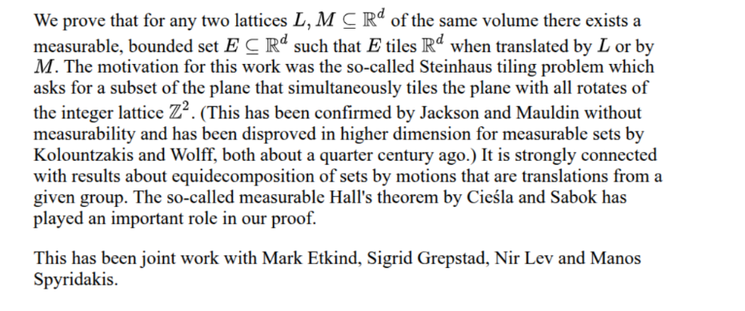

Máté Matolcsi: Improved bound on the double-cap conjecture

What is the maximal density of a measurable subset $A$ of the sphere $\mathbb{S}^n$, if $A$ does not contain orthogonal vectors? The double-cap conjecture of Gil Kalai asserts that the maximum density is achieved by two spherical caps around the North pole and the South pole. In dimension 3 (i.e. $\mathbb{S}^2$ in $\mathbb{R}^3$), this density is $1-1/\sqrt{2}=0.2929...$. We give a fairly sharp upper bound of 0.2953 by a combination of methods from harmonic analysis and linear programming. The cornerstone of our proof is the method of "geometric fractional chromatic number (GFCN)" introduced recently in connection with 1-avoiding sets in the plane. In principle, the method can be used to provide improved asymptotic bounds (as $n\to \infty).
Joint work with Domonkos Czifra, Akos Ducz, Daniel Varga, Pal Zsamboki.

